Adding a New HP Model to the Image

Contents

Injection Drivers 2

Create Package with HP MIK 2

Add to Task Sequence 6

HPIA Drivers 8

Obtaining SystemID with Softpaq Download Manager 8

PowerShell scripts 11

Required modules 11

make_new_model_collections.ps1 12

HPIA_sync_drivers.ps1 12

HPIA_make Packages.ps1 12

Add to Task Sequence 13

BIOS Configuration file 15

PXE booted 15

OS booted 15

GetBIOS.cmd (for reference) 15

Editing the BIOS Config file 15

Update the package 16

QA Task Sequence modifications 16

Review QA results 16

Move into Production 16

Production Task Sequence modifications 17

# Injection Drivers

## Create Package with HP MIK

Make sure you have HP Manageability Integration Kit (HP MIK) is installed on your machine.

<http://ftp.ext.hp.com//pub/caps-softpaq/cmit/HPMIK.html>

Note this setup will run silently for several minutes before presenting a dialog box. ConfigMgr console must be closed for the installation. The component we use is Deployment support (formerly HP Client Integration Kit). Installing the rest is optional.

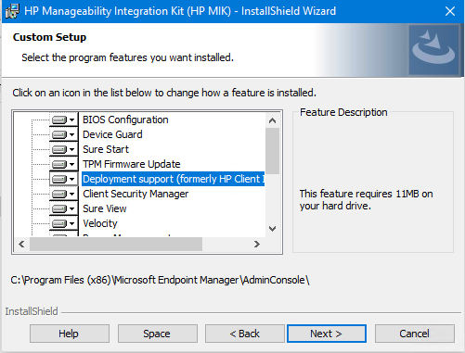

Open the ConfigMgr console and go to \Software Library\Overview\Operating Systems\Driver Packages. From the Home tab, launch “Download and Import Driver Packs”.

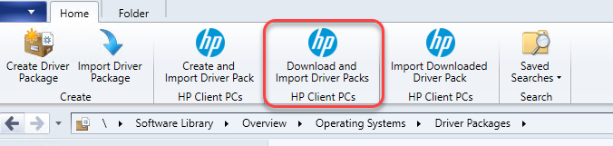

Select the Operating System from the available list. Fill in at least part of the model’s name in the HP product name field. It will bring up Available products. Select the model you want and click the “move to right” button.

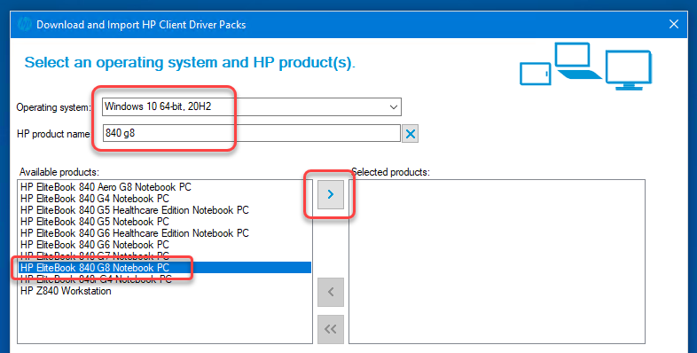

The model will be moved to Selected products and the Available driver packs list will be populated. Note the version and release date.

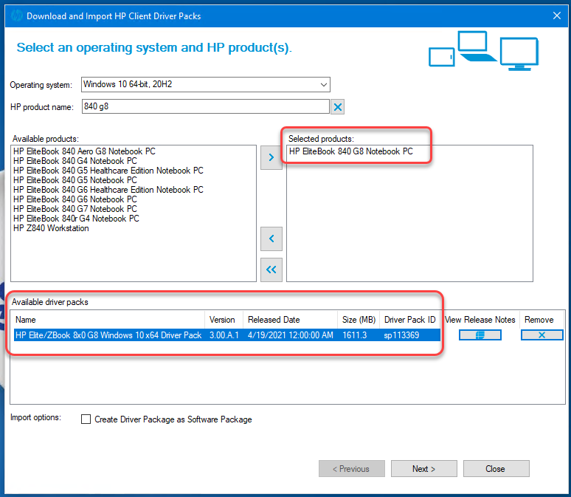

Click Next. It will offer to make a software package for additional software. We have not done this in the past (previous versions of the MIK didn’t have this and we do use HPIA for software). Uncheck the box for Create Software Package(s).

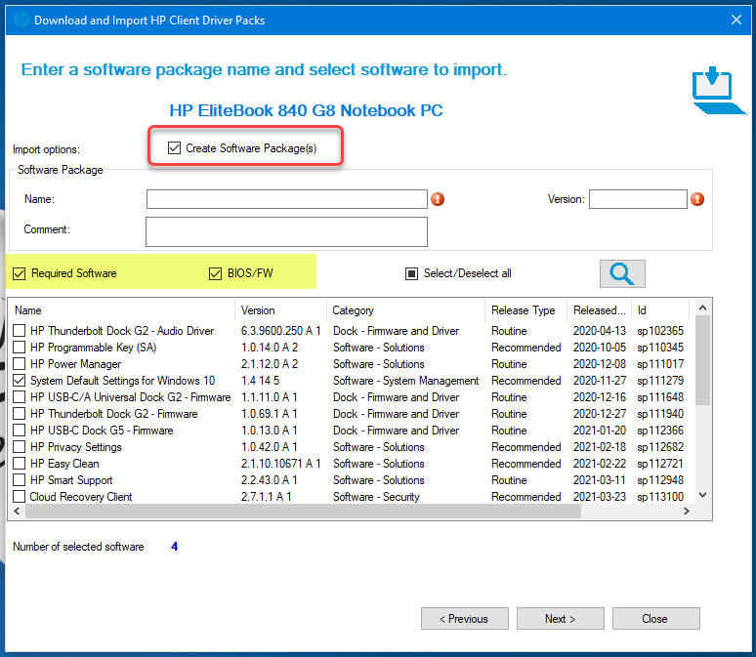

Click Next. For the Distribution point(s), select distribution points for the initial deployment and testing. For the network shares use:

Drivers: \\server\share\Drivers\SCCMDriverPackages\Win10

Driver package(s): \\server\share\Drivers\SCCMDriverPackages\Win10\pkgs

Software Package(s): \\server\share\Drivers\SCCMDriverPackages\Win10\software

Check the box to Continue on errors and select HTTPS for the protocol. Check Do not add to a task sequence. You can click save settings for later use. Click Import.

Drivers will be downloaded and imported into Operating Systems\Driver Packages\HP Client Driver Packages.

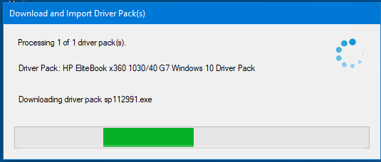

There will be a summary when the import is done.

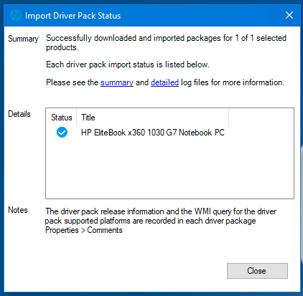

Close the summary and then the wizard when done.

And the new package is replicated to the selected distribution points.

I recommend you go into the properties and fill in the Manufacturer and Model fields.

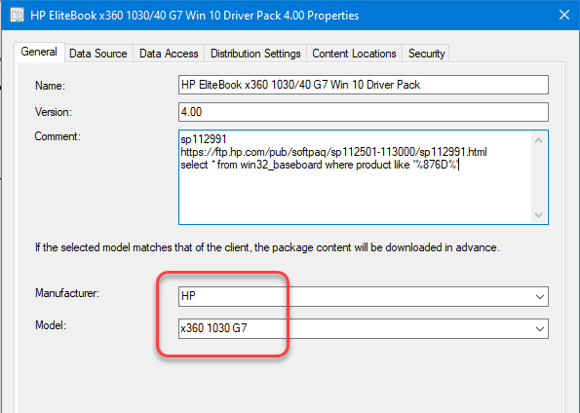

Once the packages are created and replicated, you can add them to the QA task sequence for testing. Once testing is completed replicate to All DPs and then add to the production task sequence.

## Add to Task Sequence

The injection drivers are added to the machine while it is in WinPE mode after the OS is applied but before booting to it via Child task sequence **Drivers 1 (7) QA** or **Drivers 1 (7) 1909 & 20H2** (for Prod). Add a new “Apply Driver Package” step and name it for the model similar to the existing steps. For Driver Package: click on the Browse… button and pick the newly created injection driver package. Check the box for “Do unattended installation (…)” because not all drivers are signed by the vendor. On the options tab, add a WMI Query condition for the model. For WMI Namespace use root\cimv2 and start with the text Select * From Win32_ComputerSystem WHERE Model LIKE "%<model>%". Note that you do need to keep the special, non-curly double quote marks. The percent signs are wildcards for the rest of the name. Fill in enough of the model name to identify it. Since injection driver packages are often used by multiple models, you will probably need to start the conditions with an “If ANY” clause.

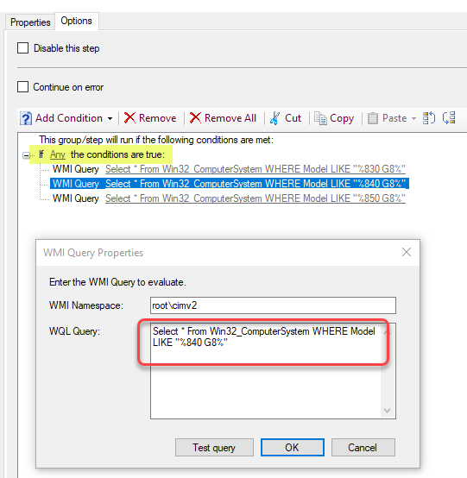

Add the injection drivers to the QA image and test, making sure the step applies as expected (use deployment report). Once that is done, replicate to All DPs. Once that is done, you can add to the production task sequence. Because this is a new step, you can copy the step from the QA task sequence and paste it into the production one.

# HPIA Drivers

There are several PowerShell scripts written to help download the drivers from HP for HPIA, to create the ConfigMgr packages from those files, and to deploy them to machines in the field. We don’t need the deployment scripts for imaging, just the sync with HP and package creation. All the scripts (and the logs created when running the scripts) are in the folder.: \\server\share\Drivers\HPDrivers\HPIA_Installed

## Obtaining SystemID with Softpaq Download Manager

First you will need to know the baseboard system ID for the new model. The easiest way to get this is using the HP Softpaq Download Manager tool (\\server\share\HPSoftPaqDownloadManager_4.4.0.0).

There is also a ConfigMgr application package of this advertised to the user collection AD Group: HP Softpaq Download Manager with direct membership and the machine collection HP Softpaq Download Manager machine push which includes all lab machines.

You may also be able to get this information from HP Image Assistant (HPIA), but I don’t know how to get data for a machine other than the one you are running HPIA on.

When you first launch HP Softpaq Download Manager you will need to specify operating system(s) to check for.

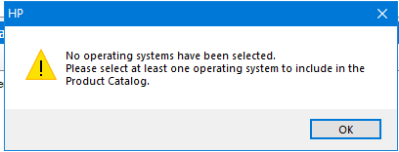

Under Filter | OS, check the box for Microsoft Windows 10 version 20H2 (64-bit). You can get back to this screen by clicking on menu item Tools | Configuration Options.

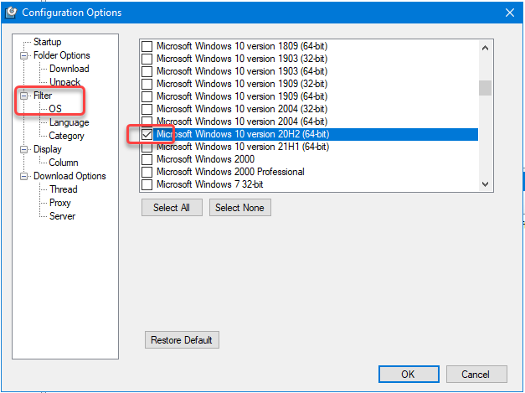

It will also automatically download the latest product catalog every day you launch it.

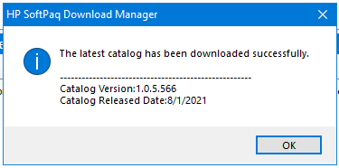

From the main screen, click on the button for Find Model. You might need to make sure Show All Products is selected (instead of Show This Computer).

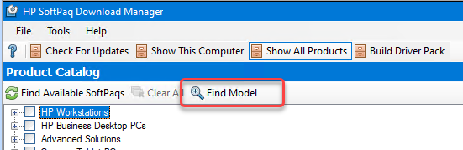

In the Find Models dialog, start typing the model name in the Model field. It will bring up matching models. Select the ones you want and click OK.

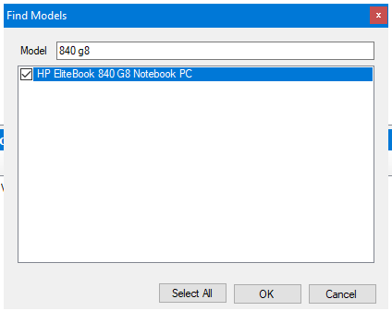

That model and OS combination will get checkmarks on the main screen of the Product Catalog.

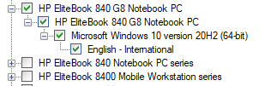

Now click the Find Available Softpaqs button.

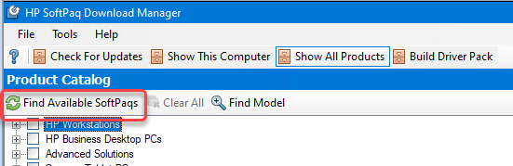

To reduce the number of Softpaqs shown click on the Show Latest Softpaqs button in the upper right.

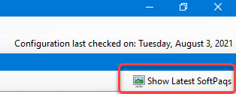

Select a Softpaq to download. I recommend the latest HP BIOS and System Firmware (sort by category) as there will always be one and it is model specific (helps later). Click the Download button.

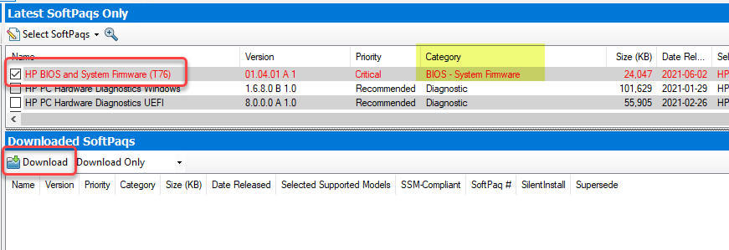

One component will be downloaded.

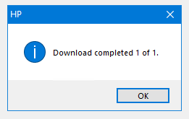

In the middle right click on the Explore | Download Directory.

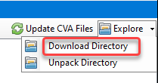

It will open a Windows Explorer window on that folder. Look for the CVA file with the same filename as the Softpaq number you just downloaded. Open it with Notepad.

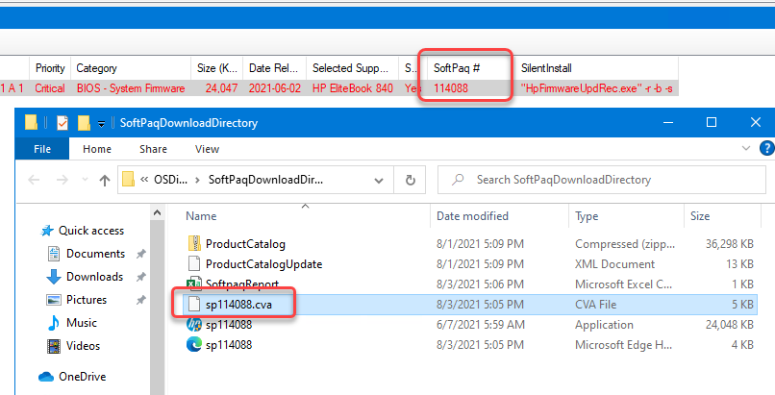

Scroll down to the [System Information] section and look for the model in the SysName## lines. Then go up to the corresponding SysID## line with the same number as the name (02 in this example). The number we need is after the “0x” (880D in this example). Often multiple models share the same system ID, as shown below. (We have both the 830 G8 and 840 G8 with SysID 880D, and 850 G8 with SysID 8846).

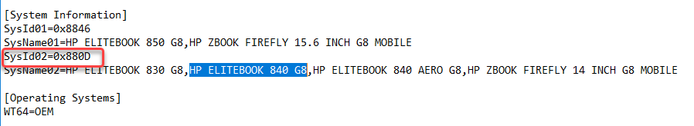

## PowerShell scripts

### Required modules

The PowerShell script to synchronize with HP require the PowerShell module hp.repo from the HP Client Management Script Library, which you can download from here: [HP Client Management Script Library | HP Client Management Solutions](https://ftp.ext.hp.com/pub/caps-softpaq/cmit/hp-cmsl.html). Online documentation is available from there too. The specific commands used are from the SoftPaq Repository section.

import-module hp.repo

The PowerShell scripts to work with ConfigMgr require the PowerShell module ConfigMgrPowerShellCmdlets, which is installed when the Configuration Manager console is installed. You can find more information about it here: [Configuration Manager PowerShell cmdlets - Configuration Manager | Microsoft Docs](https://docs.microsoft.com/en-us/powershell/sccm/overview?view=sccm-ps)

Import-Module "C:\Program Files (x86)\Microsoft Endpoint Manager\AdminConsole\bin\ConfigurationManager.psd1"

### make_new_model_collections.ps1

In folder \\server\share\Drivers\HPDrivers\HPIA_Installed, open script file **make_new_model_collections.ps1**. Edit these lines with model full name (from the CVA), model short name, chassis type, and testing collection name. SysID is used in the next script.

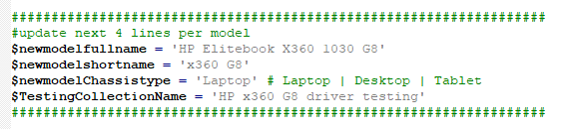

Then run it with an account that has permissions in the ConfigMgr console to create collections. It will create two collections for that model; one under All PCs | <chassis type> and one under Software Deployment\HP\driver testing that will be used in later scripts. Both collections will get membership rules.

### HPIA_sync_drivers.ps1

Then open script file **HPIA_sync_drivers.ps1**. Near the top is a section where the $HPModelsTable array is defined; you will need to add a new row to the table. Add a new row with the data from the CVA and collection script like this: (Yes, the OS is 2009 and not 20H2.) ProdCode is the SysID.

@{ ProdCode = '880D'; Model = "HP EliteBook 840 G8"; OSVER1 = 2009; OSVER2 = 1809; COLL = "HP 840 G8 driver testing" }

Comment out the other models you don’t need to synchronize with HP and run the script. It will create a new folder in \\server\share\Drivers\HPDrivers\HPIA_Installed and populate it with files from HP, the App Deployment Toolkit **template** ( \\server\share\Drivers\HPDrivers\HPIA_Installed\ADTmaster) and the HPIA **template** ( \\server\share\Drivers\HPDrivers\HPIA_Installed\HPIA Base ). You can see these template paths in the later part of the script using Robocopy. This script only copies the files from HP to a server share. This script also creates a drivers.csv file with a list of the drivers for that model that are part of the HPIA package, for reference purposes.

We will also need to run this script on a regular (quarterly?) basis for all models to keep the file share and packages up to date. The time and date stamp on the csv file can tell you when it was last synchronized.

### HPIA_make Packages.ps1

Open the script file **HPIA_make Packages.ps1**. Near the top is a section where the $HPModelsTable is defined; you will need to add a new row to the table. Add a new row with the data from the CVA and collection script like this: (Yes, the OS is 2009 and not 20H2.) Note that this table has an additional field (INC, for collection to include) that the previous script did not have.

@{ ProdCode = '880D'; Model = "HP EliteBook 840 G8"; OSVER1 = 2009; OSVER2 = 1809; COLL = "HP 840 G8 driver testing"; INC = "All HP 840 G8 Laptops"}

Comment out the other models you don’t need to synchronize with the file share and run the script. It will create the package for the HPIA drivers in \Software Library\Overview\Application Management\Packages\OS Deployment\Drivers\HP Drivers\HPIA Installed from the source folder created and synchronized above. It will create 3 programs for the package (Driver Push, Imaging, and Self Install) and two advertisements of the Self Install program to the collections (COLL & INC) created above. It will replicate the package to the distribution points for testing (make sure to replicate to All DPs before releasing to production). The package version is dated based on the activity log from the synchronization with HP, so it accurately reflects the files in the package.

Two of the programs (Imaging & Self Install) use the HP Image Assistant executable directly with this command line: Files\HPImageAssistant.exe /Operation:Analyze /Action:Install /Selection:All /Category:All /Silent /ReportFolder:"C:\Program Files (x86)\HP" /SoftpaqDownloadFolder:"Repository" /BIOSPwdFile:password /debug using either /Silent or /noninteractive as a user interface parameter. For more information about the parameters for HPImageAssistant.exe, see here: [HP Image Assistant User Guide](https://ftp.ext.hp.com/pub/caps-softpaq/cmit/whitepapers/HPIAUserGuide.pdf). The third program (Driver Push) uses both the HP Image Assistant and the PowerShell Application Deployment Toolkit. For more information on the settings for Deploy-Application.ps1, see here: \\server\share\PowerShell App Deployment Toolkit 3.8.4\PSAppDeployToolkit.pdf. The main reason to use the ADT is to get a welcome screen for the end user with a 6-hour countdown and a deferral button. The actual installation command is the same as for Self Install.

If the HPIA driver package already exists, it will be updated with the latest source files from the file share, the version updated, and synchronization to all the assigned distribution points will be triggered. Note that when replication is underway to a distribution point, imaging at that location is not available, so do not trigger the replication for existing packages used in the production image except during maintenance windows or when imaging is not in use. We do need to run this update replication on a regular (quarterly?) basis to keep all the packages used in the image up to date. Make sure you run this after the HP sync script above.

## Add to Task Sequence

The HPIA drivers are deployed to the machine while it is in the full new operating system via child task sequence **Drivers 2 (11) QA** for QA and **Drivers 2 (11) 1909 & 20H2\*\*** for production. In the appropriate section (desktop/laptop/series) add a new Install Package step. Select the newly created package and the Imaging program.

On the Options tab, create a WMI query just like for the injection drivers.

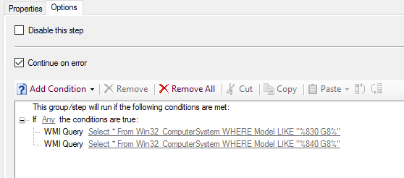

When moving to production, you can copy the line from QA and paste into the production child.

# BIOS Configuration file

You can obtain a copy of the factory BIOS Configuration settings by exporting it from the machine itself, either when PXE booted or full Windows 10 OS. Start with an export from the machine, edit it to remove settings we don’t need to modify, update the package, and apply it to a machine during imaging. Check results and iterate until there are no errors and the settings are correct.

## PXE booted

Once the new machine is PXE booted and the imaging menu is presented, press F8 to open a CMD prompt. Switch to the Z: drive and then navigate to Z:\HPBIOSConfig-4.0.15.1. Run **GetBIOS.cmd** to export the current BIOS configuration to \\server\share\BootCDSourceFiles\HPBIOSConfig-4.0.15.1 as **lab.txt**. Rename the file to reflect the model name and version (e.g. lab-840g8-1.original.txt) and move it into the Full Bios Configs folder for later reference.

## OS booted

Once the new machine is booted into the full OS, open a CMD prompt window as admin. Map a drive (Z:) to \\server\share\BootCDSourceFiles\HPBIOSConfig-4.0.15.1. Run **GetBIOS.cmd** to export the current BIOS configuration to \\server\share\BootCDSourceFiles\HPBIOSConfig-4.0.15.1 as **lab.txt**. Rename the file to reflect the model name and version (e.g. lab-840g8-1.original.txt) and move it into the Full Bios Configs folder.

### GetBIOS.cmd (for reference)

BiosConfigUtility64.exe /get:lab.txt /log /verbose /cspwdfile:password

## Editing the BIOS Config file

Make a copy of the “.original” file into the folder \\server\share\Applications\HPBIOSConfig-4.0.21.1_UEFI_QA. Rename it to <model>UEFIFull.txt.

When editing, the goal is to have as little as possible in the config file, only keeping the necessary settings. Delete the read-only settings. Keep settings we do want to change from the factory default. Keep settings that we want to make sure are a specific value. Remove settings where the factory default is what we want. Use a config file from an earlier generation of the same model for help, comparing the two using Beyond Compare. But be careful going too far back as newer settings won’t exist in old files. If there is no previous generation, look for a similar model. **Syntax is very important**; make sure to leave it as found in the export. The selected option for a setting will have an asterisk (*) next to it.

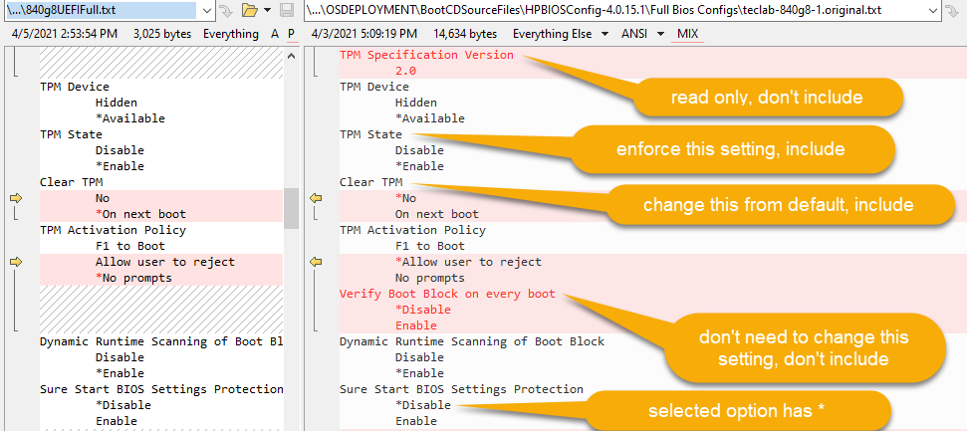

## Update the package

The QA folder above is the source for the package \Software Library\Overview\Application Management\Packages\OS Deployment\Drivers\HP Drivers\BIOS Configuration\**HP BIOS Config Utility QA UEFI (1909)**. Update that package to send the new file to the QA distribution points.

## QA Task Sequence modifications

See the instructions below for the production task sequence for editing. In the QA task sequence, the bios config is applied in the same step in Child **Preinstall (5) with BIOS update QA October 2019**, and the variable is defined in the same step in Child **Initialization (1) QA**. Modify the QA task sequence as necessary to apply the new BIOS config file. Apply the QA image to a machine of the new model.

## Review QA results

Once the image is done, check the BIOS config logs in C:\Windows\CCM\Logs. The log files will be named BiosConfigUtility-0.log for the removal of the BIOS password [<SUCCESS msg="Successfully modified Setup Password" />], BiosConfigUtility-1.txt for the main BIOS config, and BiosConfigUtility-2.log for any later configs applied. Review the logs for any errors or warnings [e.g. Setting Pre-boot DMA protection not found, will be skipped.], especially read only setting (error 19), setting not found (error 20), or invalid value (error 21). You can find the error values in \\server\share\BootCDSourceFiles\HPBIOSConfig-4.0.15.1\BIOS_Configuration_Utility_User_Guide.pdf.

Editing the BIOS config file is where the most judgement is needed during the new model intake. Sometimes the same BIOS config file can be used for several models with the same systemID; even so, not every model will have the hardware for every setting in the file.

## Move into Production

Once you are satisfied with the results in QA, copy the config file into \\server\share\Applications\HPBIOSConfig-4.0.21.1_UEFI2, which is the source folder for the production package \Software Library\Overview\Application Management\Packages\OS Deployment\Drivers\HP Drivers\BIOS Configuration\**HP BIOS Config Utility Prod UEFI G (20H2)(active)**. Don’t update this package in ConfigMgr except during an image maintenance window. Since the new file is a small text file, you can usually do this during the evening hours (Central US time). Do not edit the production task sequence (below) until this replication is complete.

## Production Task Sequence modifications

BIOS configuration is applied during imaging in child task sequence “**Preinstall (5) with BIOS update October 2019**” in a step named “Dynamic BIOS config” with the command BiosConfigUtility64.exe /set:%BIOSConfig1% /log. As you can see, the filename is a task sequence variable. That variable is defined in child task sequence “**Initialization (1)\***” in a step named “Set Dynamic Variables for Make and Model UEFI”, a Set Dynamic Variables step. Click on Add Rule | Make and Model. Fill in the Make (“HP”) and Model, matching as much as necessary with the official model name, using wildcards (* and ?) as needed. In the example below there is a * after the model name.  
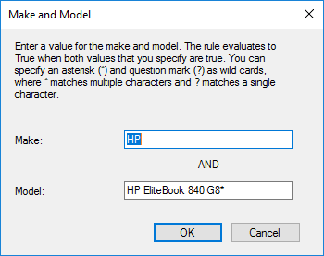

Select the new IF statement and click on Add Variable | Custom Variable. Fill in the Variable name BIOSConfig1 and the Value with the name of the BIOS config file.

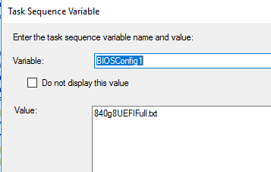

The new Make/Model entry will be added that the bottom of the list.

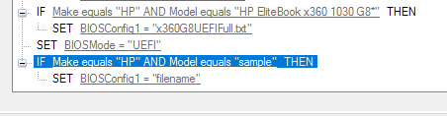

Select it and click on Move Up to position it above the “SET BIOSMode = UEFI” entry.

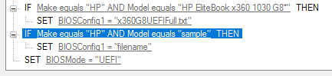

Because this is a part of a Dynamic Variable step, you cannot copy the step from QA to production; you must edit the step both places.

Once the production task sequence is edited, deploy the production image to the new model to make sure the settings are applied as desired.